**Lab 08**

**Talha Rusman**

**K23-0065**

**In lab**

**Observation and Discusstion**





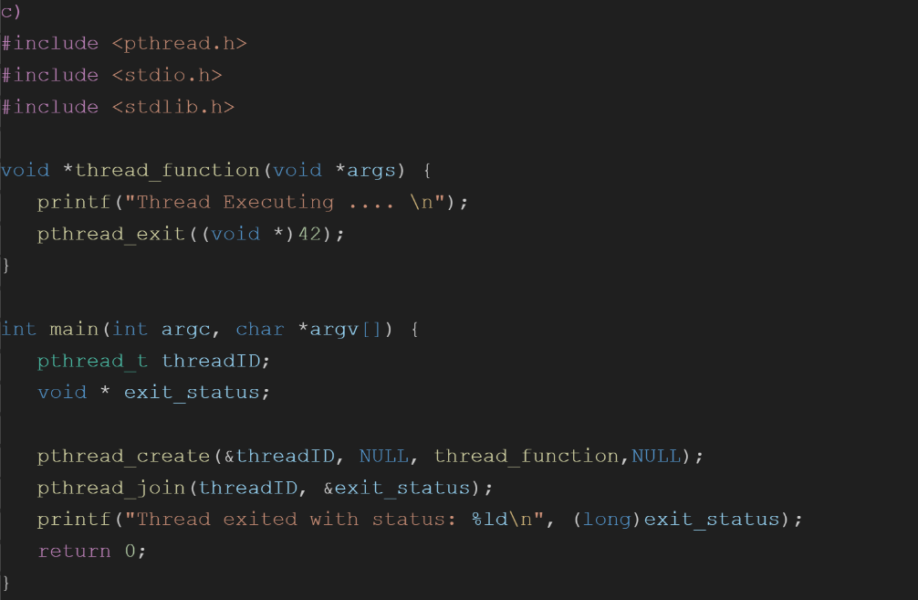

**Output**

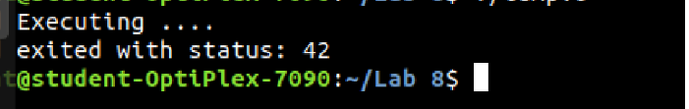

**Workout 2**

**A)**

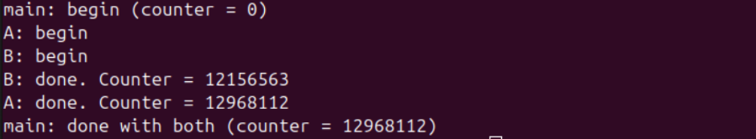

**B)**

Because counter is a global variable, when thread 1 is done with their work, it will store the value of counter, so when thread 2 starts their work, it will add to the counter value not from zero but from the value where thread 1 ends it.

**C)**

After uncomment the line 9 the output form both A and B are same B/C counter is set to 0

In function

